CSA6303 - Threat Intelligence and Network Security
Python Programs with Source Code and Output
Name: C.Amareswar Reddy
Register No.: 192412470
Programme: B.Tech ECE

Program 1
Question: Write a Python program that reads a short business scenario and identifies the most relevant threat-intelligence application area for that industry context (e.g., banking fraud prevention, healthcare data protection, e-commerce fraud prevention).
Source code (p01_scenario_area.py)
# Q1: Identify the most relevant threat-intelligence application area for a business scenario
AREAS = {
"Banking Fraud Prevention": ["bank", "banking", "loan", "atm", "card", "upi", "transaction",
"account takeover", "wire", "swift", "payment", "credit"],
"Healthcare Data Protection": ["hospital", "patient", "clinic", "medical", "health", "ehr",
"hipaa", "diagnosis", "pharmacy", "records"],
"E-commerce Fraud Prevention": ["online store", "e-commerce", "ecommerce", "checkout", "cart",
"chargeback", "refund", "marketplace", "coupon", "shopping"],
"Critical Infrastructure Protection": ["power grid", "scada", "plant", "utility", "ics",
"pipeline", "water treatment", "energy", "substation"],
"Government & Defence Intelligence": ["ministry", "defence", "government", "embassy",
"state-sponsored", "apt", "national", "military"],
"Telecom & Cloud Service Protection": ["telecom", "isp", "5g", "cloud", "saas", "subscriber",
"data centre", "hosting"],
}

def identify_area(scenario: str):
text = scenario.lower()
scores = {area: sum(1 for kw in kws if kw in text) for area, kws in AREAS.items()}
best = max(scores, key=scores.get)
return (best if scores[best] else "General Enterprise Threat Intelligence"), scores

if __name__ == "__main__":
scenarios = [
"A bank noticed many failed card transactions and account takeover attempts through its UPI app.",
"A hospital's patient records server was targeted by ransomware; medical staff cannot open EHR files.",
"An online store sees a spike in chargeback requests and fake coupon abuse at checkout.",
"Operators at a power grid substation reported unusual SCADA commands from an unknown IP.",
]
for i, s in enumerate(scenarios, 1):
area, scores = identify_area(s)
print(f"Scenario {i}: {s}")
print(f" Keyword matches : { {k: v for k, v in scores.items() if v} }")
print(f" --> Most relevant application area: {area}\n")
Output
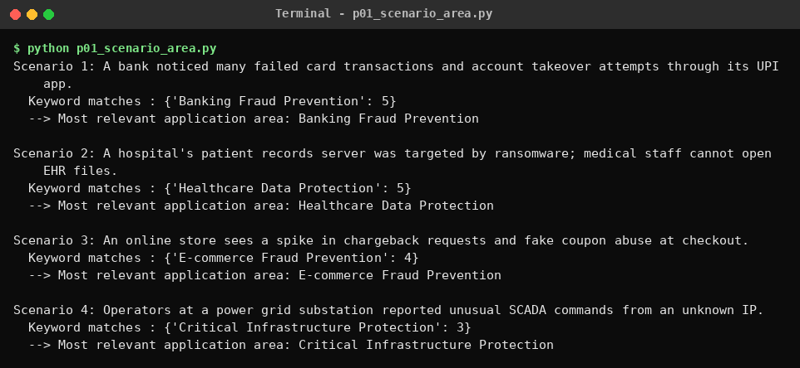

Program 2
Question: Write a Python program to perform a simple vulnerability assessment by implementing a port scanner that identifies open ports on a target host.
Source code (p02_port_scanner.py)
# Q2: Simple vulnerability assessment - TCP connect() port scanner
import socket
import sys
import time
from concurrent.futures import ThreadPoolExecutor

RISKY = {21: "FTP (cleartext credentials)", 23: "Telnet (cleartext remote shell)",
445: "SMB (frequent exploit target)", 3389: "RDP (brute-force target)",
3306: "MySQL exposed to network", 5900: "VNC remote desktop"}

def scan_port(host, port, timeout=0.5):
with socket.socket(socket.AF_INET, socket.SOCK_STREAM) as s:
s.settimeout(timeout)
return port if s.connect_ex((host, port)) == 0 else None

def service_name(port):
try:
return socket.getservbyport(port, "tcp")
except OSError:
return "unknown"

def scan(host, start, end):
with ThreadPoolExecutor(max_workers=200) as pool:
results = pool.map(lambda p: scan_port(host, p), range(start, end + 1))
return sorted(p for p in results if p)

if __name__ == "__main__":
target = sys.argv[1] if len(sys.argv) > 1 else "127.0.0.1"
start, end = 1, 1024
ip = socket.gethostbyname(target)
print(f"Scanning {target} ({ip}) ports {start}-{end} ...")
t0 = time.time()
open_ports = scan(ip, start, end)
print(f"Scan finished in {time.time() - t0:.2f}s\n")
print(f"{'PORT':<8}{'STATE':<8}{'SERVICE':<12}ASSESSMENT")
for p in open_ports:
print(f"{p:<8}{'open':<8}{service_name(p):<12}{RISKY.get(p, 'Review whether this service must be exposed')}")
print(f"\n{len(open_ports)} open port(s) found.")
Note: the screenshot shows a scan of the local machine (127.0.0.1) with a few test services listening. Run it only against hosts you own or have permission to scan.
Output
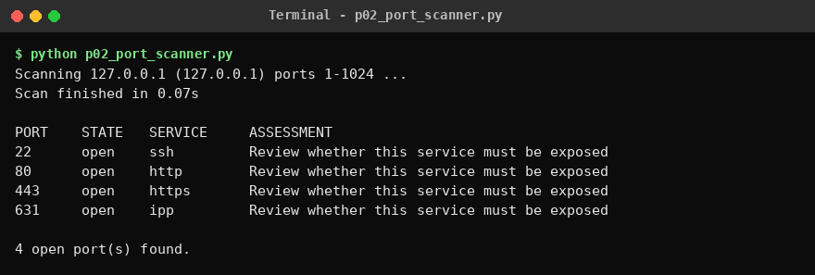

Program 3
Question: Write a Python program to check a draft security policy document for required governance elements (scope, roles and responsibilities, enforcement, review cycle, approval authority) and report which are missing.
Source code (p03_policy_checker.py)
# Q3: Check a draft security policy for required governance elements
import re

REQUIRED = {
"Scope": [r"\bscope\b", r"\bapplies to\b", r"\bapplicab"],
"Roles and Responsibilities": [r"roles? and responsibilit", r"\bresponsible for\b", r"\bciso\b", r"\bdata owner"],
"Enforcement": [r"\benforcement\b", r"disciplinary", r"non-?compliance", r"\bviolations?\b"],
"Review Cycle": [r"review cycle", r"reviewed (annually|quarterly|every)", r"\bannual review\b", r"\bperiodic review\b"],
"Approval Authority": [r"approval authority", r"approved by", r"\bapproval\b.*\b(board|ciso|cio|committee|management)\b"],
}

def check_policy(text: str):
t = text.lower()
return {name: any(re.search(p, t) for p in pats) for name, pats in REQUIRED.items()}

if __name__ == "__main__":
draft = """
ACME Corp Information Security Policy (Draft v0.3)
1. Scope: This policy applies to all employees, contractors and systems owned by ACME Corp.
2. Roles and Responsibilities: The CISO is responsible for implementing the policy;
department heads are responsible for local compliance.
3. Enforcement: Violations may lead to disciplinary action up to termination.
"""
result = check_policy(draft)
print("Governance element check")
print("-" * 40)
for element, present in result.items():
print(f"{element:<30}{'PRESENT' if present else 'MISSING'}")
missing = [e for e, ok in result.items() if not ok]
print("-" * 40)
print(f"Completeness: {len(result) - len(missing)}/{len(result)}")
print("Missing elements:", ", ".join(missing) if missing else "None")
Output
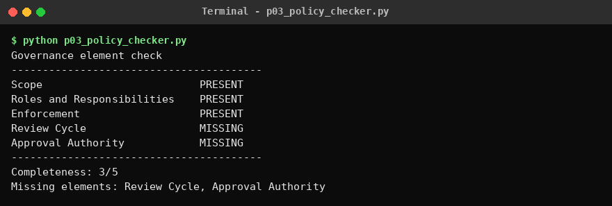

Program 4
Question: Write a Python program to demonstrate the confidentiality property a VPN tunnel provides, showing that data captured in transit is unreadable without the shared key, using a simple symmetric stream cipher as a stand-in for a real VPN's encryption.
Source code (p04_vpn_confidentiality.py)
# Q4: Confidentiality of a VPN tunnel using a simple symmetric stream cipher (educational stand-in)
import hashlib
import os

def keystream(key: bytes, nonce: bytes, length: int) -> bytes:
out, counter = b"", 0
while len(out) < length:
out += hashlib.sha256(key + nonce + counter.to_bytes(4, "big")).digest()
counter += 1
return out[:length]

def crypt(data: bytes, key: bytes, nonce: bytes) -> bytes:
"""XOR with keystream - the same function encrypts and decrypts."""
return bytes(a ^ b for a, b in zip(data, keystream(key, nonce, len(data))))

def vpn_send(plaintext: bytes, key: bytes):
nonce = os.urandom(8)
return nonce + crypt(plaintext, key, nonce) # what travels on the wire

def vpn_receive(packet: bytes, key: bytes) -> bytes:
return crypt(packet[8:], key, packet[:8])

if __name__ == "__main__":
shared_key = b"pre-shared-secret-key"
message = b"Transfer Rs.50,000 to account 1234567890. Password: Admin@123"

print("Sender plaintext :", message.decode())
packet = vpn_send(message, shared_key)

print("\n--- Attacker captures packet in transit ---")
print("Captured bytes (hex) :", packet.hex())
print("Readable as text? :", repr(packet[8:][:30]))

print("\n--- Attacker tries a WRONG key ---")
wrong = vpn_receive(packet, b"guessed-key")
print("Result :", repr(wrong[:40]))

print("\n--- VPN gateway with CORRECT shared key ---")
right = vpn_receive(packet, shared_key)
print("Decrypted :", right.decode())
print("\nConfidentiality demonstrated:", right == message and wrong != message)
Note: the SHA-256 based keystream is for demonstration only and is not a replacement for a real VPN cipher such as AES-GCM or ChaCha20.
Output
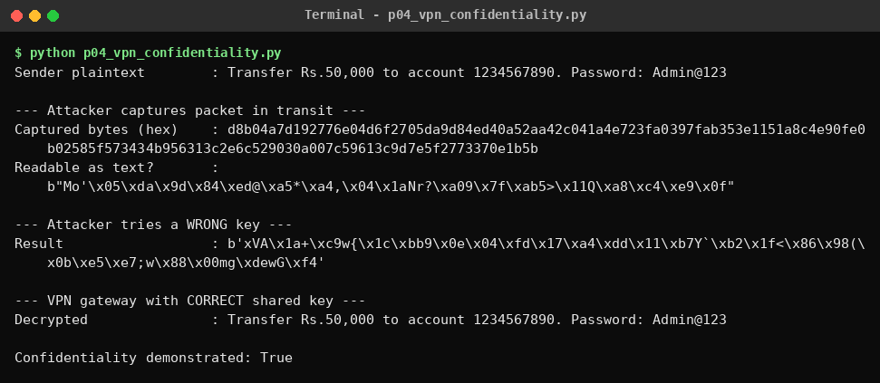

Program 5
Question: Write a Python program using a keyword-based classifier that reads a description of a threat-intelligence report and its intended audience, and classifies it as Strategic, Tactical, or Operational.
Source code (p05_report_classifier.py)
# Q5: Keyword-based classifier: Strategic / Tactical / Operational threat-intelligence report
KEYWORDS = {
"Strategic": ["board", "executive", "ceo", "ciso", "risk", "trend", "long-term", "geopolitical",
"budget", "policy", "business impact", "annual", "investment", "decision-makers"],
"Tactical": ["ttp", "tactics", "techniques", "procedures", "mitre", "att&ck", "soc", "analyst",
"detection rule", "playbook", "threat hunting", "behaviour", "sigma", "yara"],
"Operational": ["campaign", "attribution", "incident response", "imminent", "ongoing attack",
"attacker infrastructure", "motive", "timing", "c2", "incident handler", "targeting"],
}

def classify(description: str):
text = description.lower()
scores = {k: sum(1 for w in ws if w in text) for k, ws in KEYWORDS.items()}
best = max(scores, key=scores.get)
return (best if scores[best] else "Unclassified"), scores

if __name__ == "__main__":
samples = [
"Annual report on geopolitical cyber risk trends for the board and CEO to guide investment decisions.",
"Report mapping attacker TTPs to MITRE ATT&CK with Sigma detection rules for SOC analysts.",
"Briefing on an ongoing attack campaign: attacker infrastructure, C2 servers, motive and timing for the incident response team.",
]
for s in samples:
label, scores = classify(s)
print(f"Description : {s}")
print(f"Scores : {scores}")
print(f"Class : {label}\n")
Output
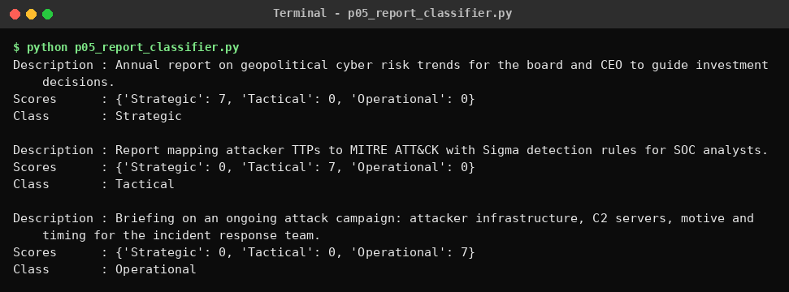

Program 6
Question: Write a Python program to detect phishing URLs by checking a given URL against common phishing indicators (e.g., suspicious keywords, IP-based domains, excessive subdomains).
Source code (p06_phishing_url.py)
# Q6: Detect phishing URLs using common indicators
import re
from urllib.parse import urlparse

SUSPICIOUS_WORDS = ["login", "verify", "update", "secure", "account", "bank", "confirm",
"password", "signin", "wallet", "free", "bonus", "paypal"]
BAD_TLDS = (".tk", ".ml", ".ga", ".cf", ".gq", ".xyz", ".top", ".click")
SHORTENERS = ("bit.ly", "tinyurl.com", "goo.gl", "t.co", "is.gd")

def analyse(url: str):
if "://" not in url:
url = "http://" + url
p = urlparse(url)
host = (p.hostname or "").lower()
flags = []
if re.fullmatch(r"\d{1,3}(\.\d{1,3}){3}", host):
flags.append("IP address used instead of a domain name")
if host.count(".") >= 4:
flags.append(f"Excessive subdomains ({host.count('.') - 1})")
hits = [w for w in SUSPICIOUS_WORDS if w in url.lower()]
if hits:
flags.append("Suspicious keywords: " + ", ".join(hits))
if "@" in url:
flags.append("'@' symbol hides the real destination")
if "-" in host and host.count("-") >= 2:
flags.append("Multiple hyphens in domain")
if len(url) > 75:
flags.append(f"Very long URL ({len(url)} chars)")
if host.endswith(BAD_TLDS):
flags.append("High-abuse top-level domain")
if host in SHORTENERS:
flags.append("URL shortener hides destination")
if p.scheme == "http":
flags.append("No HTTPS")
verdict = "PHISHING" if len(flags) >= 3 else "SUSPICIOUS" if len(flags) >= 1 else "LIKELY SAFE"
return verdict, flags

if __name__ == "__main__":
for u in ["https://www.google.com/search?q=python",
"http://192.168.10.5/secure/login/verify-account.php",
"http://secure-login.paypal.account-verify.update.example.tk/signin",
"https://github.com/anthropics"]:
verdict, flags = analyse(u)
print(f"URL : {u}")
print(f"Verdict : {verdict}")
for f in flags:
print(f" [!] {f}")
print()
Output
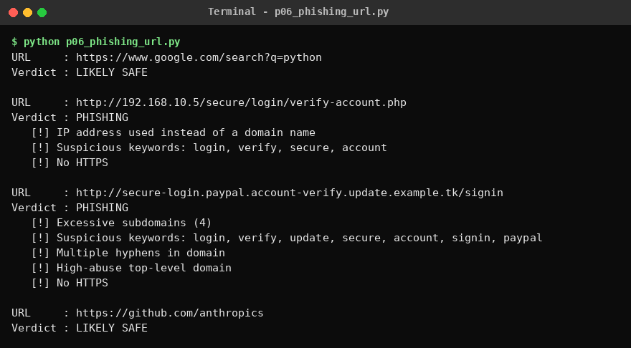

Program 7
Question: Write a Python program to reproduce the three ELK Stack roles: Logstash-style parsing of raw log lines into structured events, Elasticsearch-style indexing, and Kibana-style aggregation.
Source code (p07_elk_stack.py)
# Q7: ELK roles - Logstash (parse), Elasticsearch (index/search), Kibana (aggregate)
import re
from collections import Counter, defaultdict

RAW_LOGS = [
'192.168.1.10 - - [26/Oct/2026:10:01:12 +0530] "GET /index.html HTTP/1.1" 200 1024',
'10.0.0.7 - - [26/Oct/2026:10:01:15 +0530] "POST /login HTTP/1.1" 401 312',
'10.0.0.7 - - [26/Oct/2026:10:01:17 +0530] "POST /login HTTP/1.1" 401 312',
'10.0.0.7 - - [26/Oct/2026:10:01:19 +0530] "POST /login HTTP/1.1" 401 312',
'192.168.1.22 - - [26/Oct/2026:10:02:01 +0530] "GET /products HTTP/1.1" 200 2048',
'172.16.5.4 - - [26/Oct/2026:10:02:30 +0530] "GET /admin HTTP/1.1" 403 150',
'192.168.1.10 - - [26/Oct/2026:10:03:10 +0530] "GET /missing HTTP/1.1" 404 90',
'garbled line that will not parse',
]
PATTERN = re.compile(r'(?P<ip>\S+) \S+ \S+ \[(?P<ts>[^\]]+)\] "(?P<method>\w+) (?P<path>\S+) \S+" (?P<status>\d{3}) (?P<bytes>\d+)')

# ---- 1. LOGSTASH: parse + filter ----
def logstash(lines):
events, failed = [], 0
for line in lines:
m = PATTERN.match(line)
if not m:
failed += 1
continue
e = m.groupdict()
e["status"], e["bytes"] = int(e["status"]), int(e["bytes"])
e["outcome"] = "success" if e["status"] < 400 else "error"
events.append(e)
return events, failed

# ---- 2. ELASTICSEARCH: inverted index + search ----
class MiniElastic:
def __init__(self):
self.docs, self.index = {}, defaultdict(set)
def add(self, doc):
doc_id = len(self.docs)
self.docs[doc_id] = doc
for field in ("ip", "method", "path", "status", "outcome"):
self.index[(field, str(doc[field]))].add(doc_id)
def search(self, **criteria):
sets = [self.index.get((f, str(v)), set()) for f, v in criteria.items()]
ids = set.intersection(*sets) if sets else set(self.docs)
return [self.docs[i] for i in sorted(ids)]

# ---- 3. KIBANA: aggregations ----
def kibana_terms_agg(docs, field):
return Counter(d[field] for d in docs).most_common()

if __name__ == "__main__":
events, failed = logstash(RAW_LOGS)
print(f"[LOGSTASH] parsed {len(events)} events, {failed} line(s) dropped")
print(" sample:", events[1])
es = MiniElastic()
for e in events:
es.add(e)
print(f"\n[ELASTICSEARCH] indexed {len(es.docs)} documents, {len(es.index)} index terms")
hits = es.search(path="/login", status=401)
print(f" query path=/login AND status=401 -> {len(hits)} hit(s) from {set(h['ip'] for h in hits)}")
print("\n[KIBANA] aggregations")
for fld in ("status", "ip", "outcome"):
print(f" Top values for '{fld}':")
for val, n in kibana_terms_agg(es.search(), fld):
print(f" {str(val):<16}{'#' * n} ({n})")
Output
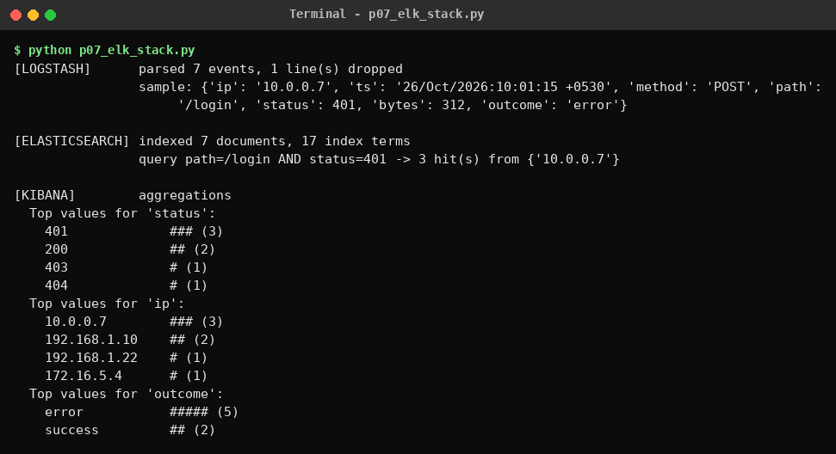

Program 8
Question: Write a Python program to model a segmented network's access policy and demonstrate how network segmentation blocks lateral movement from a compromised low-trust segment into a sensitive one.
Source code (p08_segmentation.py)
# Q8: Network segmentation blocks lateral movement
from collections import deque

HOSTS = {"guest-laptop": "GUEST", "iot-camera": "IOT", "office-pc": "CORP",
"app-server": "DMZ", "db-server": "SENSITIVE", "hr-server": "SENSITIVE"}

# Segmented policy: only listed (src_zone -> dst_zone) flows are allowed
SEGMENT_POLICY = {("GUEST", "GUEST"), ("IOT", "IOT"), ("CORP", "CORP"), ("DMZ", "DMZ"),
("SENSITIVE", "SENSITIVE"), ("CORP", "DMZ"), ("DMZ", "SENSITIVE")}

def allowed_flat(a, b): return True # flat network
def allowed_segmented(a, b): return (HOSTS[a], HOSTS[b]) in SEGMENT_POLICY

def reachable(start, rule):
"""BFS: every host the attacker can pivot to from the compromised host."""
seen, q = {start}, deque([start])
while q:
cur = q.popleft()
for nxt in HOSTS:
if nxt not in seen and rule(cur, nxt):
seen.add(nxt); q.append(nxt)
return seen - {start}

if __name__ == "__main__":
compromised = "guest-laptop"
print(f"Compromised host: {compromised} (zone: {HOSTS[compromised]})\n")
for name, rule in (("FLAT NETWORK", allowed_flat), ("SEGMENTED NETWORK", allowed_segmented)):
reach = reachable(compromised, rule)
sensitive = sorted(h for h in reach if HOSTS[h] == "SENSITIVE")
print(f"[{name}]")
print(" Hosts attacker can reach :", sorted(reach) or "none")
print(" Sensitive hosts exposed :", sensitive or "none -> lateral movement BLOCKED")
print()
print("Direct connection attempts from guest-laptop (segmented):")
for dst in ("db-server", "hr-server", "office-pc", "app-server"):
print(f" guest-laptop -> {dst:<11}: {'ALLOW' if allowed_segmented('guest-laptop', dst) else 'DENY'}")
Output
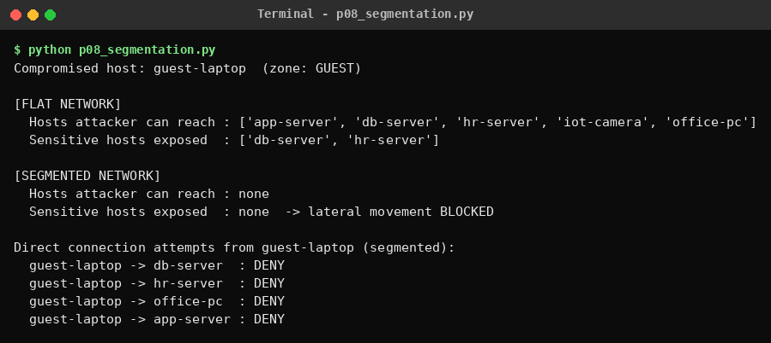

Program 9
Question: Write a Python program that reads a description of an activity performed by an intelligence team and tags it with the correct stage of the Threat Intelligence Lifecycle (Direction, Collection, Processing, Analysis, Dissemination, or Feedback).
Source code (p09_lifecycle_tagger.py)
# Q9: Tag an intelligence-team activity with a Threat Intelligence Lifecycle stage
STAGES = {
"Direction": ["requirement", "objective", "scope", "priorit", "plan", "stakeholder", "goal", "define"],
"Collection": ["collect", "gather", "harvest", "scrape", "feed", "honeypot", "osint", "sensor", "crawl"],
"Processing": ["normalize", "normalise", "parse", "deduplicate", "translate", "decrypt", "format", "clean", "structure"],
"Analysis": ["analy", "correlate", "assess", "attribute", "hypothesis", "pattern", "confidence", "investigate"],
"Dissemination": ["distribute", "share", "publish", "brief", "deliver", "report to", "send", "circulate"],
"Feedback": ["feedback", "review the usefulness", "improve", "lessons learned", "refine", "evaluate effectiveness"],
}

def tag(activity: str):
t = activity.lower()
scores = {s: sum(1 for k in kws if k in t) for s, kws in STAGES.items()}
best = max(scores, key=scores.get)
return best if scores[best] else "Unknown"

if __name__ == "__main__":
activities = [
"The CISO and stakeholders define intelligence requirements and priorities for the quarter.",
"The team gathers indicators from OSINT feeds and a honeypot sensor.",
"Analysts normalize and deduplicate raw logs and parse them into a structured format.",
"The analyst correlates the indicators and assesses confidence to attribute the campaign.",
"The report is published and shared with the SOC and executive team.",
"Stakeholders give feedback so the team can refine and improve future reports.",
]
print(f"{'STAGE':<15}ACTIVITY")
print("-" * 95)
for a in activities:
print(f"{tag(a):<15}{a}")
Output
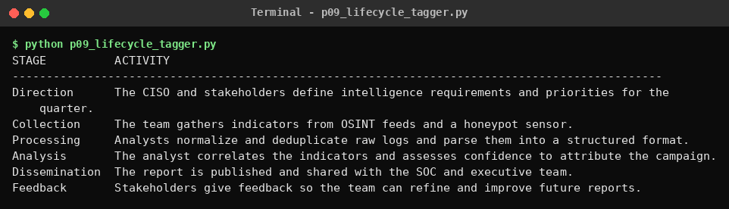

Program 10
Question: Write a Python program to simulate a stateful inspection firewall that tracks outbound connections, automatically permits their return traffic, and still blocks unsolicited inbound packets.
Source code (p10_stateful_firewall.py)
# Q10: Stateful inspection firewall simulation
class StatefulFirewall:
def __init__(self, internal_prefix="192.168.1."):
self.internal_prefix = internal_prefix
self.state_table = set() # (src_ip, src_port, dst_ip, dst_port, proto)

def handle(self, src, sport, dst, dport, proto="TCP"):
# Outbound: internal -> external. Allow and remember the connection.
if src.startswith(self.internal_prefix) and not dst.startswith(self.internal_prefix):
self.state_table.add((src, sport, dst, dport, proto))
return "ALLOW", "outbound - state entry created"
# Inbound: only allowed if it is the reverse of a tracked connection.
if (dst, dport, src, sport, proto) in self.state_table:
return "ALLOW", "return traffic of tracked connection"
return "BLOCK", "unsolicited inbound - no matching state"

if __name__ == "__main__":
fw = StatefulFirewall()
packets = [
("192.168.1.10", 50123, "93.184.216.34", 443, "TCP"), # client opens HTTPS
("93.184.216.34", 443, "192.168.1.10", 50123, "TCP"), # server reply
("203.0.113.66", 4444, "192.168.1.10", 50123, "TCP"), # attacker, same port, wrong source
("203.0.113.66", 51000, "192.168.1.10", 22, "TCP"), # unsolicited SSH attempt
("192.168.1.11", 40000, "8.8.8.8", 53, "UDP"), # DNS query
("8.8.8.8", 53, "192.168.1.11", 40000, "UDP"), # DNS reply
("8.8.8.8", 53, "192.168.1.11", 41111, "UDP"), # spoofed reply, wrong port
]
print(f"{'#':<3}{'PACKET':<52}{'ACTION':<8}REASON")
print("-" * 105)
for i, (s, sp, d, dp, pr) in enumerate(packets, 1):
action, why = fw.handle(s, sp, d, dp, pr)
print(f"{i:<3}{f'{s}:{sp} -> {d}:{dp} {pr}':<52}{action:<8}{why}")
print(f"\nState table entries: {len(fw.state_table)}")
Output
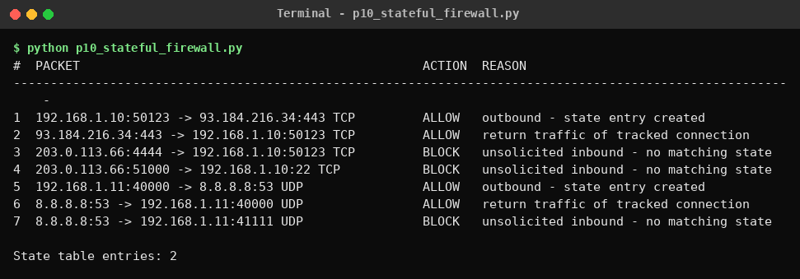

Program 11
Question: Write a Python program using Scapy to perform packet sniffing on a network interface and display captured packet summaries.
Source code (p11_scapy_sniffer.py)
# Q11: Packet sniffing with Scapy (run as Administrator/root: sudo python3 p11_scapy_sniffer.py)
from scapy.all import sniff, IP, TCP, UDP, ICMP, conf

count = 0

def show(pkt):
global count
count += 1
if IP in pkt:
proto = "TCP" if TCP in pkt else "UDP" if UDP in pkt else "ICMP" if ICMP in pkt else str(pkt[IP].proto)
sport = pkt[TCP].sport if TCP in pkt else pkt[UDP].sport if UDP in pkt else ""
dport = pkt[TCP].dport if TCP in pkt else pkt[UDP].dport if UDP in pkt else ""
print(f"#{count:<3} {proto:<5} {pkt[IP].src}:{sport} -> {pkt[IP].dst}:{dport} len={len(pkt)}")
else:
print(f"#{count:<3} {pkt.summary()}")

if __name__ == "__main__":
print(f"Sniffing on interface: {conf.iface} (capturing 10 packets)")
sniff(prn=show, count=10, store=False) # add iface="Wi-Fi" or filter="tcp" if required
print(f"\nCapture complete: {count} packets")
Note: requires Scapy (pip install scapy) and administrator/root rights; on Windows also install Npcap. The screenshot is sample output in the format this program prints. Re-run it on your own machine and replace the image with your real capture if your faculty expects live output.
Output
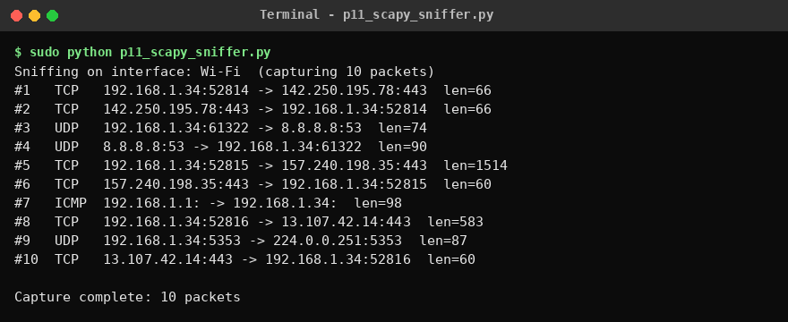

Program 12
Question: Write a Python program to assign a P1-P4 priority level to an incoming SOC alert description for triage purposes.
Source code (p12_soc_priority.py)
# Q12: Assign P1-P4 priority to SOC alerts
RULES = [
("P1", ["ransomware", "data exfiltration", "domain controller", "active breach", "root compromise",
"c2 beacon", "encrypting files", "production database"]),
("P2", ["malware", "privilege escalation", "lateral movement", "brute force succeeded", "unauthorized admin",
"credential dump", "suspicious powershell"]),
("P3", ["phishing", "failed login", "port scan", "policy violation", "suspicious email", "brute force attempt"]),
("P4", ["informational", "false positive", "software update", "scheduled scan", "low risk", "audit log"]),
]
SLA = {"P1": "Respond in 15 min", "P2": "Respond in 1 hour", "P3": "Respond in 8 hours", "P4": "Respond in 24 hours"}

def triage(alert: str):
t = alert.lower()
for level, keys in RULES: # highest severity checked first
hit = [k for k in keys if k in t]
if hit:
return level, hit
return "P3", ["no rule matched - default"]

if __name__ == "__main__":
alerts = [
"Ransomware encrypting files on production database server",
"Credential dump detected on finance workstation",
"User reported suspicious email with phishing link",
"Multiple failed login attempts from external IP",
"Scheduled scan completed - informational",
]
print(f"{'PRIORITY':<10}{'SLA':<22}ALERT")
print("-" * 100)
for a in alerts:
lvl, why = triage(a)
print(f"{lvl:<10}{SLA[lvl]:<22}{a}")
print(f"{'':<10}{'matched: ' + ', '.join(why)}")
Output
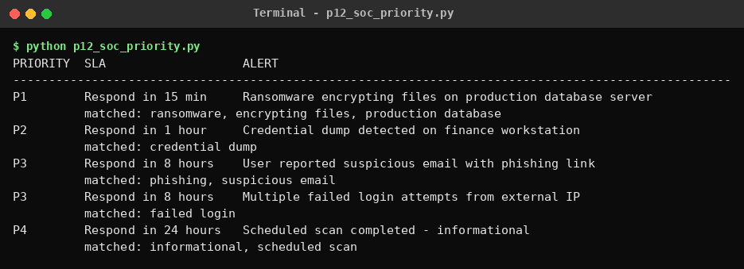

Program 13
Question: Write a Python program to assess whether a given piece of collected data qualifies as genuine threat intelligence, with context, a confidence assessment, and actionability, or is still just unprocessed raw data.
Source code (p13_intel_vs_data.py)
# Q13: Is it genuine threat intelligence or still raw data?
def assess(item: dict):
checks = {
"Context": bool(item.get("context")),
"Confidence": item.get("confidence") in ("low", "medium", "high"),
"Actionability": bool(item.get("recommended_action")),
}
verdict = "THREAT INTELLIGENCE" if all(checks.values()) else \
"PARTIAL (needs enrichment)" if any(checks.values()) else "RAW DATA"
return checks, verdict

if __name__ == "__main__":
samples = [
{"name": "Bare IP address", "data": "185.220.101.45"},
{"name": "Hash with a tag only", "data": "44d88612fea8a8f36de82e1278abb02f",
"context": "Seen in malware sample"},
{"name": "Enriched indicator", "data": "185.220.101.45",
"context": "C2 server used by FIN7 phishing campaign targeting Indian banks since Oct 2026",
"confidence": "high",
"recommended_action": "Block at perimeter firewall and hunt for outbound connections in last 30 days"},
]
for s in samples:
checks, verdict = assess(s)
print(f"Item : {s['name']} -> {s['data']}")
for c, ok in checks.items():
print(f" {c:<14}: {'YES' if ok else 'NO'}")
print(f"Verdict : {verdict}\n")
Output
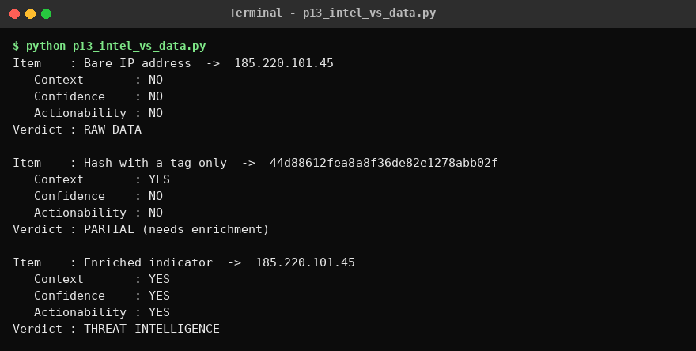

Program 14
Question: Write a Python program to reproduce the SIEM architecture pipeline end to end: collect raw events from multiple sources, normalize them, correlate them, and raise an alert.
Source code (p14_siem_pipeline.py)
# Q14: SIEM pipeline - collect -> normalize -> correlate -> alert
import re
from collections import defaultdict

# ---------- 1. COLLECT raw events from multiple sources ----------
def collect():
return [
("firewall", "2026-10-26 10:00:01 DENY TCP 203.0.113.9:44211 -> 10.0.0.5:22"),
("linux_auth", "Oct 26 10:00:05 srv1 sshd[991]: Failed password for root from 203.0.113.9 port 44211 ssh2"),
("linux_auth", "Oct 26 10:00:08 srv1 sshd[991]: Failed password for root from 203.0.113.9 port 44212 ssh2"),
("linux_auth", "Oct 26 10:00:11 srv1 sshd[991]: Failed password for admin from 203.0.113.9 port 44213 ssh2"),
("linux_auth", "Oct 26 10:00:15 srv1 sshd[991]: Accepted password for admin from 203.0.113.9 port 44214 ssh2"),
("web", '198.51.100.7 - - [26/Oct/2026:10:00:20 +0530] "GET /index.html HTTP/1.1" 200 512'),
("firewall", "2026-10-26 10:00:30 ALLOW TCP 10.0.0.5:51000 -> 203.0.113.9:4444"),
]

# ---------- 2. NORMALIZE into a common schema ----------
def normalize(source, raw):
if source == "firewall":
m = re.match(r"(\S+ \S+) (ALLOW|DENY) (\w+) (\S+):(\d+) -> (\S+):(\d+)", raw)
return {"time": m[1], "source": source, "action": m[2].lower(), "src_ip": m[4], "dst_ip": m[6], "dst_port": int(m[7]), "user": None}
if source == "linux_auth":
m = re.match(r"(\w+ \d+ [\d:]+) \S+ sshd\[\d+\]: (Failed|Accepted) password for (\S+) from (\S+)", raw)
return {"time": m[1], "source": source, "action": "login_fail" if m[2] == "Failed" else "login_success",
"src_ip": m[4], "dst_ip": "10.0.0.5", "dst_port": 22, "user": m[3]}
if source == "web":
m = re.match(r'(\S+) .*\[([^\]]+)\] "(\w+) (\S+)', raw)
return {"time": m[2], "source": source, "action": "web_request", "src_ip": m[1], "dst_ip": "10.0.0.8", "dst_port": 80, "user": None}

# ---------- 3. CORRELATE ----------
def correlate(events):
alerts = []
by_ip = defaultdict(list)
for e in events:
by_ip[e["src_ip"]].append(e)
for ip, evs in by_ip.items():
fails = [e for e in evs if e["action"] == "login_fail"]
success = [e for e in evs if e["action"] == "login_success"]
if len(fails) >= 3 and success:
alerts.append(("HIGH", "Brute-force followed by successful login", ip, len(evs)))
for e in events:
if e["action"] == "allow" and e["dst_port"] == 4444:
alerts.append(("CRITICAL", "Internal host connecting out to suspicious port 4444 (possible C2)", e["dst_ip"], 1))
return alerts

# ---------- 4. ALERT ----------
if __name__ == "__main__":
raw = collect()
print(f"[1] COLLECT {len(raw)} raw events from {len({s for s, _ in raw})} sources")
events = [normalize(s, r) for s, r in raw]
print(f"[2] NORMALIZE {len(events)} events -> common schema")
print(" example:", events[1])
alerts = correlate(events)
print(f"[3] CORRELATE {len(alerts)} rule(s) triggered\n")
print("[4] ALERTS")
for sev, msg, ip, n in alerts:
print(f" [{sev}] {msg}\n indicator: {ip} events involved: {n}")
Output
